1. **Agenda**: We want to decrement the “**in_stock**” value by one without knowing its current value.
2. **Solution**: We can do this with so called 🡺 **Scripted Update.**
3. Elasticsearch supports scripting which enables you to write custom logic while accessing a document’s values.  
   In this example, we can increase or decrease the “**in_stock**” field’s value.
4. You can think of scripting as custom code that looks like a programming language.
5. To use script, we will use Update API, as we did use in the previous lecture.
6. Just specify “script” object in request body.
7. ctx: Context.  
   ctx._source: To access **source document** on which we want to perform scripting using the _source property on ctx.  
    Through ctx._source, you can now access the document’s fields 🡺 ctx._source.**fieldName**Inthis example, we added script on a single line which is ideal for very simple script.   
   For advanced script, you can use three double quotes at the beginning and end of the script instead of one.  
   This marks the string as a multiline string allowing your script to span multiple lines.  
   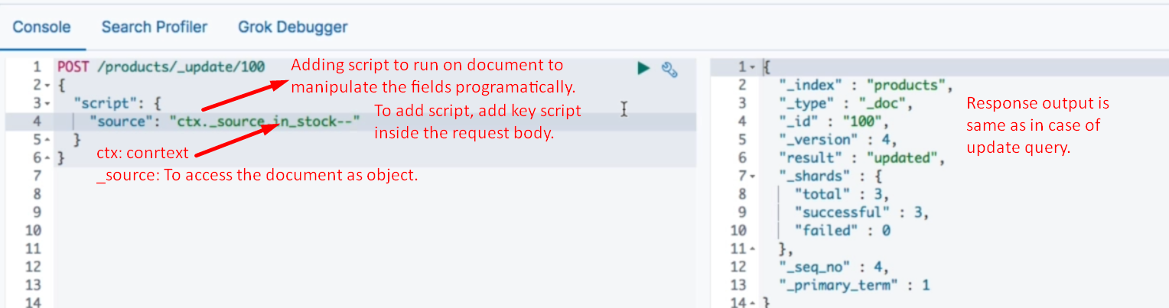
8. We can do assignment too.  
   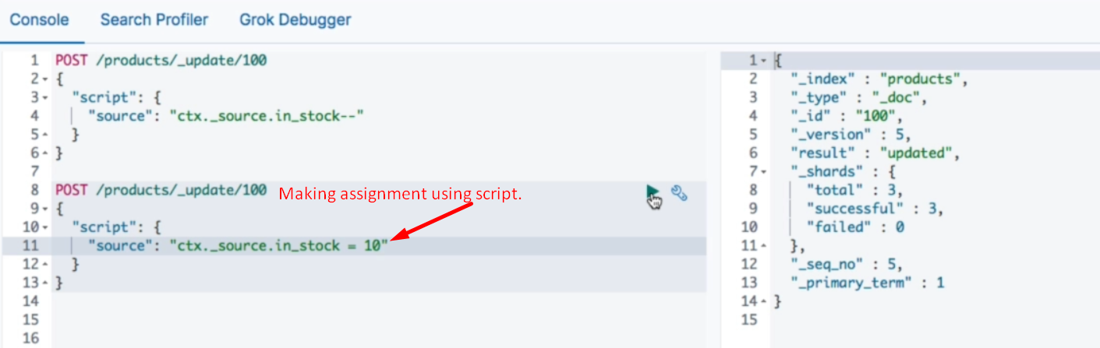
9. 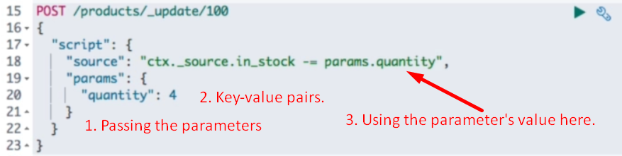

**NOTE**: The above use is useful when someone purchase 4 items so instead of decrement by one we’re passing the parameters from the application.

1. There are two other possible values for result key specified in result query apart from “updated”.  
   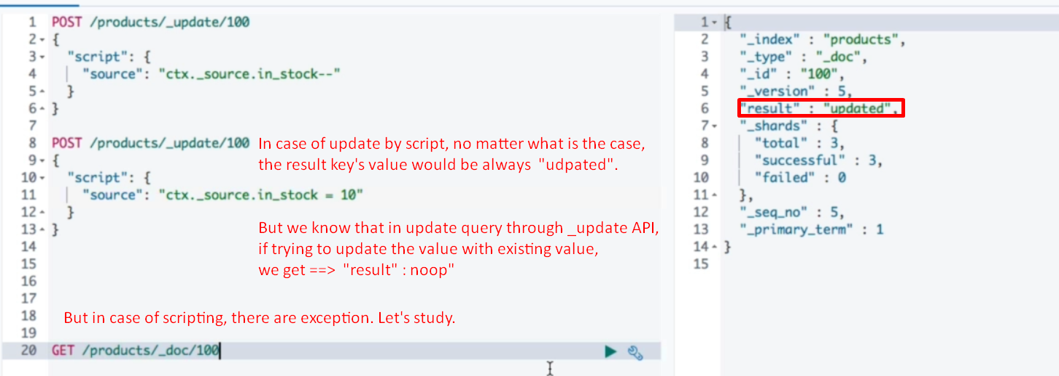
2. 